# Tour New York

Take advantage of this **incredible** deals an see New york City this fall for only $1,250. the five-day vist include’s both airfar and lodgeing.

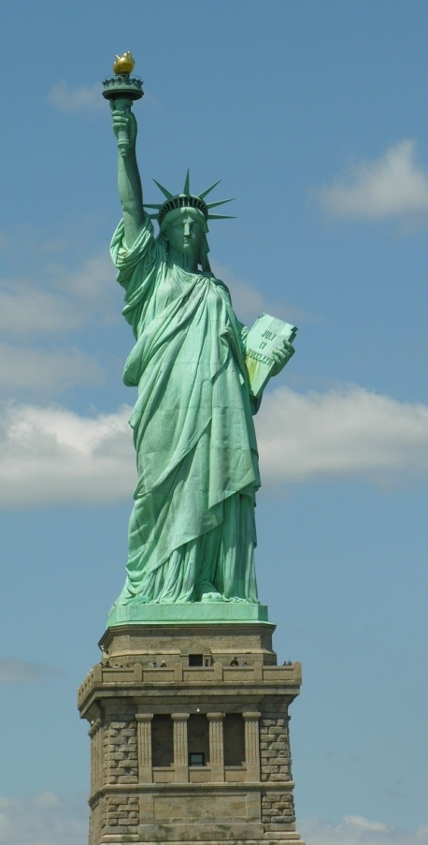

* Daily continentel breaksfast provided
* Discount event tickets and admision coupons fr area area attractions
* Limited group tours available

## *Call bay Travel reservations at 555-6788!*